IBM Blockchain
Proof of Technology
Demo Scenarios Hands On
Lab42 Exercises

Contents
Section 1. Accessing the Demo environment 4
1.1. Install the blockchain and start the peer (optional) 4
1.2. Verify blockchain is running 4
Section 2. Cooling Degrees Days derivative Scenario 6
2.1. Scenario: Create a contract 7
2.1.1. Implementing overridden methods 9
2.1.2. Implementing initialization and invocation methods 11
2.2. Deployment and testing 15
2.2.1. Local testing 15
2.2.2. Deployment 15
2.2.3. Interact with your chaincode 17
Section 3. Building an app for your Blockchain 19
3.1. Prerequesites 19
3.1. Create a web app 19
Appendix A. Trademarks and copyrights 23

Overview
This lab will give you a hands on demonstration of the example use case of Cooling Degrees Days derivatives where a farmer will agree a contract with an insurer and a payment will be executed each time a threshold degree has been reached on a specific location.

Introduction
Pre Requisites:
  - 2 cores
  - 4GB RAM
  - Postman
  - Eclipse
  - Java >v1.8
  - Maven & Gradle

It is recommended to use the Blockchain network already deployed on a server to win time.

Otherwise, if you want to use the Blockchain in local you need to:
  - Install Docker Engine (native) >v1.11
  - Get 2 Hyperledger Docker images (hyperledger/fabric-peer, hyperledger/fabric-javaenv) in v0.6

Icons
The following symbols appear in this document at places where additional guidance is available.

Icon | Purpose | Explanation
 | Important! | This symbol calls attention to a particular step or command. For example, it might alert you to type a command carefully because it is case sensitive.
 | Information | This symbol indicates information that might not be necessary to complete a step, but is helpful or good to know.
 | Trouble-shooting | This symbol indicates that you can fix a specific problem by completing the associated troubleshooting information.

Accessing the Demo environment

The IBM Blockchain is on fabric-peer Docker image but the Java Docker images will be necessary when starting a new container. We will use one validating peer only for the use of the demo.

Install the blockchain and start the peer (optional)

If you decided to use the Blockchain network already set, pass to next chapter

- Verify that Docker daemon is running. Launch “docker” command on a Terminal for example

- Open a Terminal window and load the 2 docker images :

docker load –i fabricpeer.tar
docker load –i javaenv.tar

(or in case you do not have access to theses images, take these ones from “hyperledger”)
docker pull hyperledger/fabric-peer:x86_64-0.6.1-preview
docker pull hyperledger/fabric-javaenv:x86_64-0.6.1-preview

- To verify images in local :

docker images

Output should contain :

- Then run a peer typing :

docker run --name vp0 -it -e CORE_VM_ENDPOINT=unix:///var/run/docker.sock -v /var/run/docker.sock:/var/run/docker.sock -p 7050:7050 -e CORE_LOGGING_LEVEL=DEBUG -e CORE_PEER_ID=vp0 -e CORE_PEER_ADDRESSAUTODETECT=true hyperledger/fabric-peer peer node start

You should see the peer logs
Don’t forget to add the docker ‘tag’ of the image if necessary. Ex : hyperledger/fabric-javaenv:x86_64-0.6.1-preview

Verify blockchain is running

- Launch Postman

- Test if the Blockchain is running calling :

GET http://169.50.153.154:7050/chain
Check the IP before clicking on button Send. Leave default IP pointing to the blockchain network or point to your localhost if you use it locally.

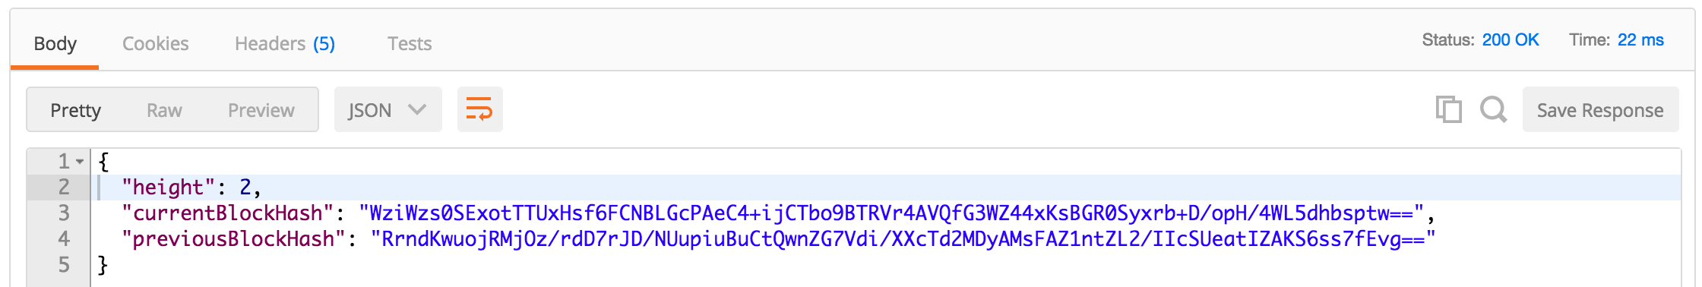

You should have a response 200 OK with this kind of payload.

If you got an error or timeout, verify the logs to see if the blockchain is running correctly.

Well done, the Blockchain is running. Let’s go to implement some chaincode on next chapter

Cooling Degrees Days derivative Scenario

In the following sections you will discover how Blockchain technology can be used to sign contract between a farmer and an insurer and then trigger changes on the contract’s state. The goal of a CDD derivative is an insurance for famers to hedge against poor harvests caused by failing rains during the growing period, excessive rain during harvesting, high winds in case of plantations or temperature variabilities in case of greenhouse crops. In a CDD case, every time the average day degree passes under a threshold, a client could receive a payment, it smooths earnings.

- Creating a contract between a farmer and an insurer
- Executing a contract based on a specific location
- Querying the contract State to know if the farmer has received a payment


Farmer
Insurer

In this business scenario each participant has entered into a business agreement with each other and all parties are known and trusted by each other. For each contract deployment, one instance of the java project is running on the Blockchain. For our example, we will create only one contract between two people, but you can do as many as you want.

This demo has been simplified in the way:

- No security has been enabled and configured. You can do it as an extra exercise.
- We trust and assume that calls to Weather API will send back always the same value for each peer. We also trust Weather API data as a trustable oracle
- We do any calls we want, normally in a real case, the contract should be called at end of month or year
- The contract should contain a start and end date validity. You can do it as an extra exercise

Scenario: Create a contract

In the following section you will code a CDD derivative chaincode contract in Java using Hyperledger.

- Import JavaCDD project into Eclipse (get it from USB key or pull code from Github here : https://github.com/zamrokk/JavaCDD and then remove the class com.ibm.JavaCDD)

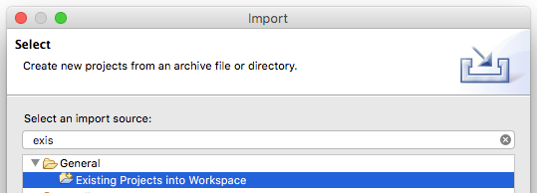

- Have a look on the project structure. You have the choice to use Maven or Gradle for development but Gradle will be necessary at deployment and it is used by Hyperledger.

At the moment, you have 2 POJOs class files :
ContractRecord
WeatherObservationResponse

You have a test class available : JavaCDDTest

You will be asked to code JavaCDD class file right now that extends ChaincodeBase

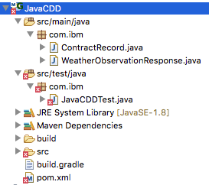

- Create new class JavaCDD, declare logger and add a main method. That is all for the moment.

package com.ibm;

/**
* <h1>Chaincode using external weather API to trigger cooling degrees days
* contract</h1>
*
*/
public class JavaCDD extends ChaincodeBase {
private static Log log = LogFactory.getLog(JavaCDD.class);

public static void main(String[] args) throws Exception {
new JavaCDD().start(args);
}
…

- The class does not compile because is missing dependency for class ChaincodeBase. Have a look on pom.xml and build.gradle

Maven

<dependency>
<groupId>org.hyperledger</groupId>
<artifactId>shim-client</artifactId>
<version>1.0</version>
</dependency>

Gradle

compile 'org.hyperledger:shim-client:1.0'

You will have 2 choices to get this artifact :

- Build the project from the Hyperledger’s source code here : https://gerrit.hyperledger.org/r/p/fabric.git
At this path “/usr/local/go/src/github.com/hyperledger/fabric/core/chaincode/shim/java”, run “gradle build”. Then get the jar.
- Search on this lab folder and find the file named “shim-client-1.0.jar”. Add it to maven local repo or project deps.

Do not worry about Hyperledger, it will compile itself this jar and it will ba available on its local .m2

- Now you can do a “maven install” or “gradle build”. Both should compile fine.

Implementing overridden methods

- Name your code identifier for easier read (optional use)

@Override
/**
* Just a easiest way to retrieve a contract by its name
*/
public String getChaincodeID() {
return "JavaCDD";
}

- Start coding the entrypoint method named “run”. It is the interface for “INVOKE” and “DEPLOY” API calls. Init function is used for deployment and all others for invocations.

@Override
/**
* Entry point of invocation interaction
*
* @param stub
* @param function
* @param args
*/
public String run(ChaincodeStub stub, String function, String[] args) {
log.info("In run, function:" + function);
switch (function) {
case "init":
init(stub, function, args);
break;
case "executeContract":
String re = executeContract(stub, args);
log.info("Return of executeContract : " + re);
return re;
default:
String warnMessage = "{\"Error\":\"Error function " + function + " not found\"}";
log.warn(warnMessage);
return warnMessage;
}
return null;
}

- Last overidden method is “query”. We will have to retrieve the contract state and return it back to the client. Do as below :

/**
* This function can query the current State of the contract
* @param stub
* @param function
* @param args
* client name
* @return total amount received for this client
*/
@Override
public String query(ChaincodeStub stub, String function, String[] args) {
if (args.length != 1) {
return "{\"Error\":\"Incorrect number of arguments. Expecting name of the client to query\"}";
}
String clientName = stub.getState(args[0]);
log.info("Called " + function + " on client : " + clientName);
if (clientName != null && !clientName.isEmpty()) {
try {
ObjectMapper mapper = new ObjectMapper();
ContractRecord contractRecord = mapper.readValue(clientName, ContractRecord.class);
return "" + contractRecord.totalAmountReceived;
} catch (Exception e) {
return "{\"Error\":\"Failed to parse state for client " + args[0] + " : " + e.getMessage() + "\"}";
}
} else {
return "{\"Error\":\"Failed to get state for client " + args[0] + "\"}";
}
}

Implementing initialization and invocation methods

- At deployment we will need to initialize the contract. Copy code below

/**
* This function initializes the contract
* @param stub
* @param function
* @param args
* client name, temperature threshold, amount received when
* contract is activated
* @return
*/
public String init(ChaincodeStub stub, String function, String[] args) {
if (args.length != 3) {
return "{\"Error\":\"Incorrect number of arguments. Expecting 3 : client name, temperature threshold, amount received when contract is activated \"}";
}
try {
ContractRecord contractRecord = new ContractRecord(args[0], Integer.parseInt(args[1]),Integer.parseInt(args[2]));
stub.putState(args[0], contractRecord.toString());
} catch (NumberFormatException e) {
return "{\"Error\":\"Expecting integer value for temperature threshold and amount received\"}";
}
return null;
}

- Then, here is the main piece. We are coding the contract on a specific location passed as parameters. An API call to Weather API will return the current temperature and will compare it against the threshold of the contract. If the temperature is below, then the client will have its account credited with the redemption agreement amount of the contract, otherwise nothing happens.
(Credentials of the service API have been hardcoded, you can change this value with your own credentials on Bluemix or use another external API or device to get a temperature value)

/**
* This function calls Weather API to check if the temperature on a location
* is inferior to the contract's threshold. If yes, the client is redeemed
* for the value agreed on the contract
*
* @param stub
* @param args
* client name, postal Code, country Code
* @return
*/
public String executeContract(ChaincodeStub stub, String[] args) {
log.info("in executeContract");
Boolean contractExecuted = false;

if (args.length != 3) {
String errorMessage = "{\"Error\":\"Incorrect number of arguments. Expecting 3: client name, postal Code, country Code\"}";
log.error(errorMessage);
return errorMessage;
}
ObjectMapper mapper = new ObjectMapper();
ContractRecord contractRecord;
try {
contractRecord = mapper.readValue(stub.getState(args[0]), ContractRecord.class);
} catch (Exception e1) {

String errorMessage = "{\"Error\":\" Problem retrieving state of client contract : " + e1.getMessage()+ " \"}";
log.error(errorMessage);
return errorMessage;
}

String postalCode = args[1];
String countryCode = args[2];

// weather service
String url = "https://twcservice.mybluemix.net/api/weather/v1/location/" + postalCode + "%3A4%3A" + countryCode
+ "/observations.json?language=en-GB";

HttpClient httpclient = new DefaultHttpClient();
HttpGet httpget = new HttpGet(url);

SSLSocketFactory sf;
try {
SSLContext sslContext = SSLContext.getInstance("TLS");
sslContext.init(null, null, null);
sf = new SSLSocketFactory(sslContext);
} catch (Exception e1) {
String errorMessage = "{\"Error\":\" Problem with SSLSocketFactory : " + e1.getMessage() + " \"}";
log.error(errorMessage);
return errorMessage;
}

sf.setHostnameVerifier(SSLSocketFactory.ALLOW_ALL_HOSTNAME_VERIFIER);
Scheme sch = new Scheme("https", sf, 443);
httpclient.getConnectionManager().getSchemeRegistry().register(sch);

((AbstractHttpClient) httpclient).getCredentialsProvider().setCredentials(
new AuthScope(AuthScope.ANY_HOST, AuthScope.ANY_PORT),
new UsernamePasswordCredentials("dfa7551a-2613-4f5c-bff7-339649770aa5", "gvbmK5JsGO"));

HttpResponse response;
try {
response = httpclient.execute(httpget);

log.info("Called Weather service");

int statusCode = response.getStatusLine().getStatusCode();

HttpEntity httpEntity = response.getEntity();
String responseString = EntityUtils.toString(httpEntity);

if (statusCode == HttpStatus.SC_OK) {

log.info("Weather service call OK");

WeatherObservationResponse weatherObservationResponse = mapper.readValue(responseString,WeatherObservationResponse.class);

if (weatherObservationResponse.getObservation().getTemp() < contractRecord.temperatureThreshold) {
// then please redeem the client
contractRecord.totalAmountReceived += contractRecord.amountReceivedWhenContractIsActivated;
stub.putState(contractRecord.clientName, contractRecord.toString());
log.info("Contract condition valid " + weatherObservationResponse.getObservation().getTemp() + " < "
+ contractRecord.temperatureThreshold);
contractExecuted=true;
} else {
log.info("Contract condition invalid " + weatherObservationResponse.getObservation().getTemp()+ " > " + contractRecord.temperatureThreshold);
}

} else {
String errorMessage = "{\"Error\":\"Problem while calling Weather API : " + statusCode + " : "+ responseString + "\"}";
log.error(errorMessage);
return errorMessage;
}

} catch (Exception e) {
String errorMessage = "{\"Error\":\"Problem while calling Weather API : " + e.getMessage() + "\"}";
log.error(errorMessage);
try {
log.error(new ObjectMapper().writerWithDefaultPrettyPrinter().writeValueAsString(e.getStackTrace()));
} catch (JsonProcessingException e2) {
e2.printStackTrace();
}
return errorMessage;
}

return contractExecuted.toString();
}

Deployment and testing

Local testing

We will use Mockito to mocked the Blockchain and see if what we wrote is actually working

For more info about mockito : http://site.mockito.org/

- On your project, go to folder /src/test/java. You will find a class named JavaCDDTest.
There are two Junit test cases on it. “Nice” test case should always execute the contract but not increment the client’s account and “Fairbanks” should increment.

Logs and Eclipse debug mode should be enough for you to check how the amount has changed.

- Launch the Junit tests. Right click on project or test file and click “Run as > JUnit Test” or “Debug as > JUnit Test”

All tests should have passed green. Check then the logs, to see if scenarios have run has expected. If you are not sure, run on debug mode and add breakpoints to your code

Deployment

As your chaincode is running correctly locally with a mocked Blockchain, it is time to deploy it on the real one.

To deploy a chaincode we will use the HTTP API with Postman

- Open Postman and call :

POST http://169.50.153.154:7050/chaincode

Where body contains

{
"jsonrpc": "2.0",
"method": "deploy",
"params": {
"type": 4,
"chaincodeID": {
"path": "https://github.com/zamrokk/JavaCDD"
},
"ctorMsg": {
"args": ["init","farmer","10", "42"]
}
},
"id": 1
}

Change the red path to your chaincode project path. You can use http:// or file:/// path but be sure that is accessible from your Blockchain environment, otherwise upload will fail. We recommend to use your URL.

You should have a 200 OK

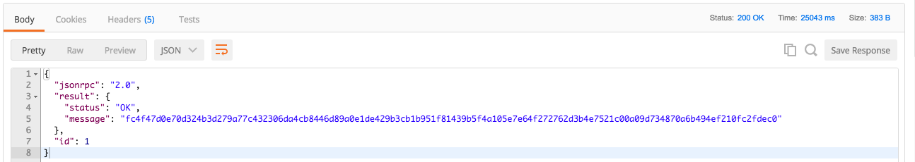

In the Json, copy the value of result>message. It is the unique identifier of your chaincode, you will need it for after. You could use the ChaincodeID you have coded, but in case of several deployment of the same chaincode, it can cause some duplicate ID problems

- Call the query you coded to see if the default amount has been initialized

POST http://169.50.153.154:7050/chaincode

Where body contains

{
"jsonrpc": "2.0",
"method": "query",
"params": {
"type": 4,
"chaincodeID": {
"name": "fc4f47d0e70d324b3d279a77c432306da4cb8446d89a0e1de429b3cb1b951f81439b5f4a105e7e64f272762d3b4e7521c00a09d734870a6b494ef210fc2fdec0"
},
"ctorMsg": {
"args":["query","farmer"]
}
},
"id": 2
}

You should have a zero amount on the message returned

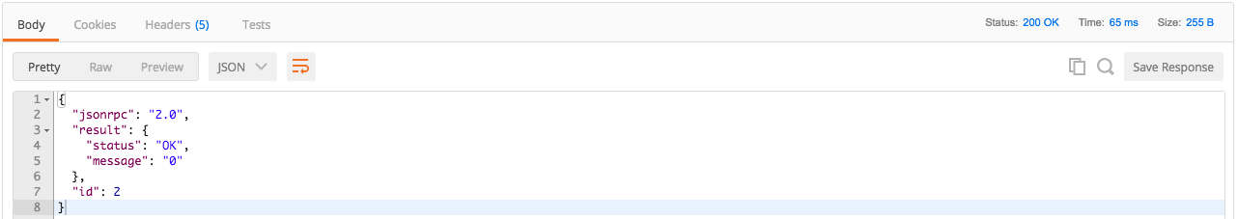

Interact with your chaincode

- Open Postman and call :

POST http://169.50.153.154:7050/chaincode

Where body contains

{
"jsonrpc": "2.0",
"method": "invoke",
"params": {
"type": 1,
"chaincodeID": {
"name": "fc4f47d0e70d324b3d279a77c432306da4cb8446d89a0e1de429b3cb1b951f81439b5f4a105e7e64f272762d3b4e7521c00a09d734870a6b494ef210fc2fdec0"
},
"ctorMsg": {
"args":["executeContract","farmer","99701", "US"]
}
},
"id": 2
}

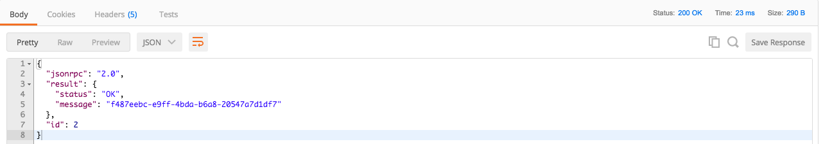

Let’s call the query to check the result

POST http://169.50.153.154:7050/chaincode

Where body contains

{
"jsonrpc": "2.0",
"method": "query",
"params": {
"type": 4,
"chaincodeID": {
"name": "fc4f47d0e70d324b3d279a77c432306da4cb8446d89a0e1de429b3cb1b951f81439b5f4a105e7e64f272762d3b4e7521c00a09d734870a6b494ef210fc2fdec0"
},
"ctorMsg": {
"args":["query","farmer"]
}
},
"id": 2
}

You should have an amount with value 42 on the message returned

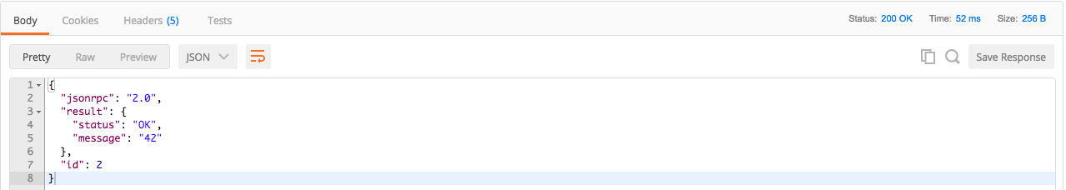

Congratulations, you have successfully invoked your chaincode and incremented the client account. You know can now:
- Change location parameters while invoking chaincode
- Changing the code adding begin and end date validity checks
- Plug to another external API service

Building an app for your Blockchain

We will build a client application in Angular2 to interact with the Blockchain

Prerequesites

- Go to https://nodejs.org/en/download/ to install npm (v3)
- Open a terminal and install Angular CLI : (if access denied,search on google npm access permissions issue)
npm install –g angular-cli

Create a web app

- Open Eclipse, right click New>Maven Project
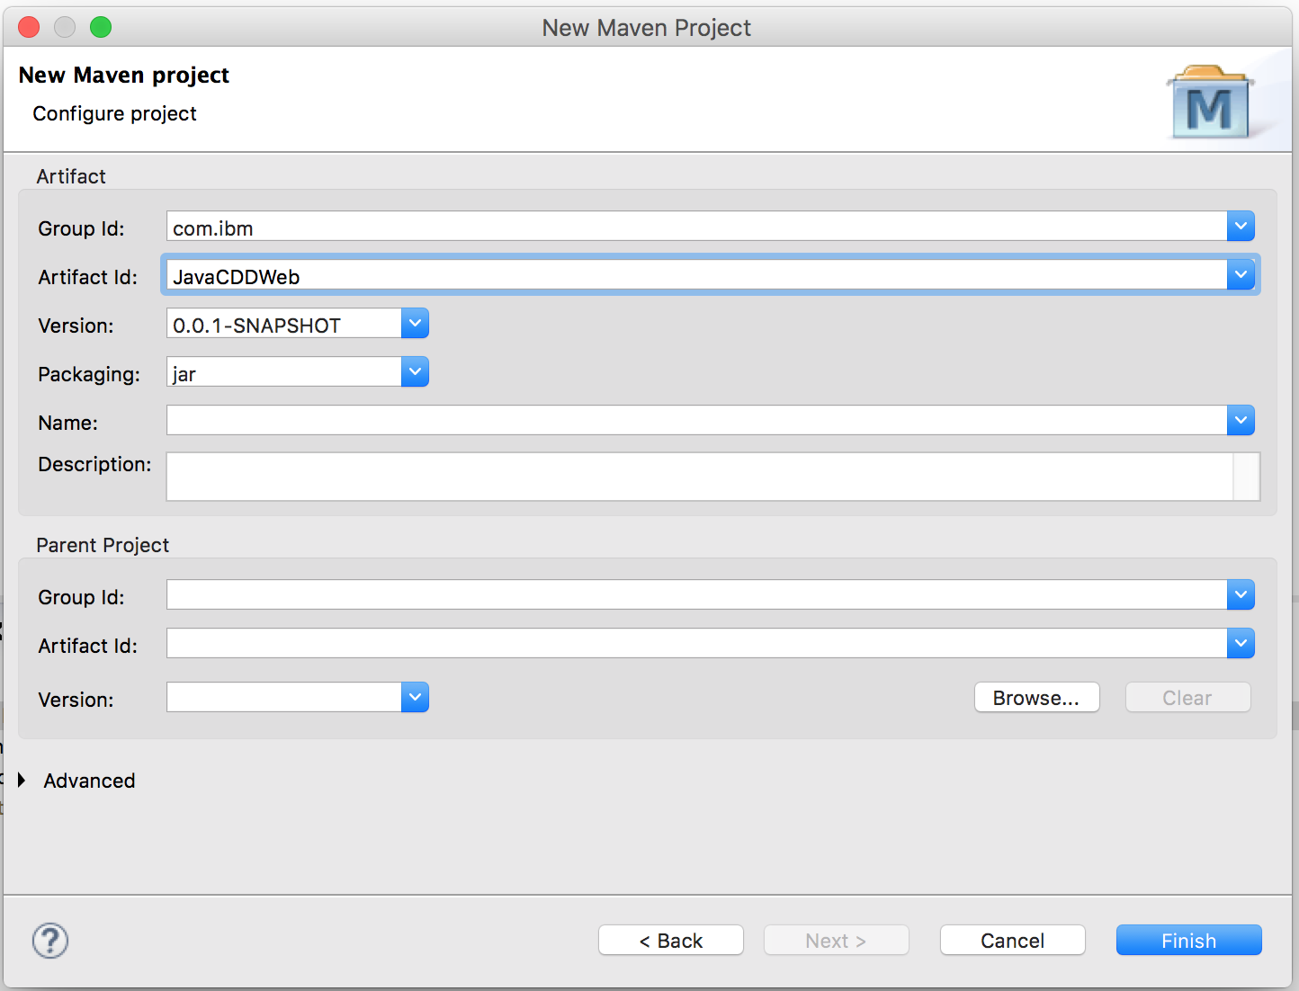
- Open pom.xml and edit it like this

- Open a terminal on the project root, go to folder src/main/resources and type
ng init

Notices

This information was developed for products and services offered in the U.S.A.
IBM may not offer the products, services, or features discussed in this document in other countries. Consult your local IBM representative for information on the products and services currently available in your area. Any reference to an IBM product, program, or service is not intended to state or imply that only that IBM product, program, or service may be used. Any functionally equivalent product, program, or service that does not infringe any IBM intellectual property right may be used instead. However, it is the user's responsibility to evaluate and verify the operation of any non-IBM product, program, or service.
IBM may have patents or pending patent applications covering subject matter described in this document. The furnishing of this document does not grant you any license to these patents. You can send license inquiries, in writing, to:
IBM Director of Licensing
IBM Corporation
North Castle Drive
Armonk, NY 10504-1785
U.S.A.
For license inquiries regarding double-byte (DBCS) information, contact the IBM Intellectual Property Department in your country or send inquiries, in writing, to:
IBM World Trade Asia Corporation
Licensing
2-31 Roppongi 3-chome, Minato-ku
Tokyo 106-0032, Japan
The following paragraph does not apply to the United Kingdom or any other country where such provisions are inconsistent with local law: INTERNATIONAL BUSINESS MACHINES CORPORATION PROVIDES THIS PUBLICATION "AS IS" WITHOUT WARRANTY OF ANY KIND, EITHER EXPRESS OR IMPLIED, INCLUDING, BUT NOT LIMITED TO, THE IMPLIED WARRANTIES OF NON-INFRINGEMENT, MERCHANTABILITY OR FITNESS FOR A PARTICULAR PURPOSE. Some states do not allow disclaimer of express or implied warranties in certain transactions, therefore, this statement may not apply to you.
This information could include technical inaccuracies or typographical errors. Changes are periodically made to the information herein; these changes will be incorporated in new editions of the publication. IBM may make improvements and/or changes in the product(s) and/or the program(s) described in this publication at any time without notice.
Any references in this information to non-IBM Web sites are provided for convenience only and do not in any manner serve as an endorsement of those Web sites. The materials at those Web sites are not part of the materials for this IBM product and use of those Web sites is at your own risk.
IBM may use or distribute any of the information you supply in any way it believes appropriate without incurring any obligation to you.
Any performance data contained herein was determined in a controlled environment. Therefore, the results obtained in other operating environments may vary significantly. Some measurements may have been made on development-level systems and there is no guarantee that these measurements will be the same on generally available systems. Furthermore, some measurements may have been estimated through extrapolation. Actual results may vary. Users of this document should verify the applicable data for their specific environment.
Information concerning non-IBM products was obtained from the suppliers of those products, their published announcements or other publicly available sources. IBM has not tested those products and cannot confirm the accuracy of performance, compatibility or any other claims related to non-IBM products. Questions on the capabilities of non-IBM products should be addressed to the suppliers of those products.
All statements regarding IBM's future direction and intent are subject to change or withdrawal without notice, and represent goals and objectives only.
This information contains examples of data and reports used in daily business operations. To illustrate them as completely as possible, the examples include the names of individuals, companies, brands, and products. All of these names are fictitious and any similarity to the names and addresses used by an actual business enterprise is entirely coincidental. All references to fictitious companies or individuals are used for illustration purposes only.
COPYRIGHT LICENSE:
This information contains sample application programs in source language, which illustrate programming techniques on various operating platforms. You may copy, modify, and distribute these sample programs in any form without payment to IBM, for the purposes of developing, using, marketing or distributing application programs conforming to the application programming interface for the operating platform for which the sample programs are written. These examples have not been thoroughly tested under all conditions. IBM, therefore, cannot guarantee or imply reliability, serviceability, or function of these programs.
- Trademarks and copyrights
The following terms are trademarks of International Business Machines Corporation in the United States, other countries, or both:
IBM | AIX | CICS | ClearCase | ClearQuest | Cloudscape
Cube Views | DB2 | developerWorks | DRDA | IMS | IMS/ESA
Informix | Lotus | Lotus Workflow | MQSeries | OmniFind
Rational | Redbooks | Red Brick | RequisitePro | System i
System z | Tivoli | WebSphere | Workplace | System p
Adobe, the Adobe logo, PostScript, and the PostScript logo are either registered trademarks or trademarks of Adobe Systems Incorporated in the United States, and/or other countries.
IT Infrastructure Library is a registered trademark of the Central Computer and Telecommunications Agency which is now part of the Office of Government Commerce.
Intel, Intel logo, Intel Inside, Intel Inside logo, Intel Centrino, Intel Centrino logo, Celeron, Intel Xeon, Intel SpeedStep, Itanium, and Pentium are trademarks or registered trademarks of Intel Corporation or its subsidiaries in the United States and other countries.
Linux is a registered trademark of Linus Torvalds in the United States, other countries, or both.
Microsoft, Windows, Windows NT, and the Windows logo are trademarks of Microsoft Corporation in the United States, other countries, or both.
ITIL is a registered trademark, and a registered community trademark of The Minister for the Cabinet Office, and is registered in the U.S. Patent and Trademark Office.
UNIX is a registered trademark of The Open Group in the United States and other countries.
Java and all Java-based trademarks and logos are trademarks or registered trademarks of Oracle and/or its affiliates.
Cell Broadband Engine is a trademark of Sony Computer Entertainment, Inc. in the United States, other countries, or both and is used under license therefrom.
Linear Tape-Open, LTO, the LTO Logo, Ultrium, and the Ultrium logo are trademarks of HP, IBM Corp. and Quantum in the U.S. and other countries.



© Copyright IBM Corporation 2014.
The information contained in these materials is provided for informational purposes only, and is provided AS IS without warranty of any kind, express or implied. IBM shall not be responsible for any damages arising out of the use of, or otherwise related to, these materials. Nothing contained in these materials is intended to, nor shall have the effect of, creating any warranties or representations from IBM or its suppliers or licensors, or altering the terms and conditions of the applicable license agreement governing the use of IBM software. References in these materials to IBM products, programs, or services do not imply that they will be available in all countries in which IBM operates. This information is based on current IBM product plans and strategy, which are subject to change by IBM without notice. Product release dates and/or capabilities referenced in these materials may change at any time at IBM’s sole discretion based on market opportunities or other factors, and are not intended to be a commitment to future product or feature availability in any way.
IBM, the IBM logo and ibm.com are trademarks of International Business Machines Corp., registered in many jurisdictions worldwide. Other product and service names might be trademarks of IBM or other companies. A current list of IBM trademarks is available on the Web at “Copyright and trademark information” at www.ibm.com/legal/copytrade.shtml.


